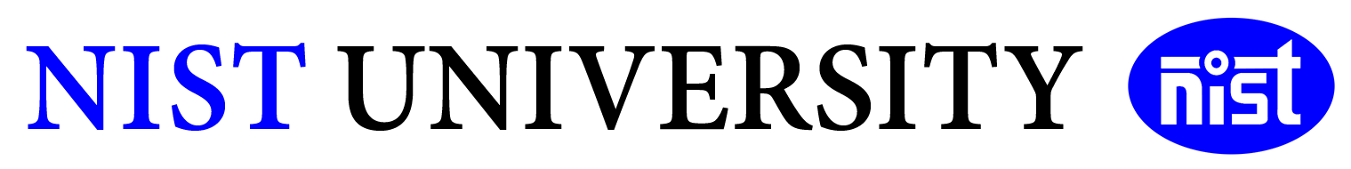
Academic Year: 2025-2026
Subject- Design and Analysis of Algorithms
Code- CSE-200
Semester-3rd Sem Batch- 2024 Section- D

Student Name | Roll Number
Maruti Nandan Dash | 202456482
Tusar Kant Swain | 202456485

Title of the Project-
SKELETON EXTRACTION FROM IMAGES

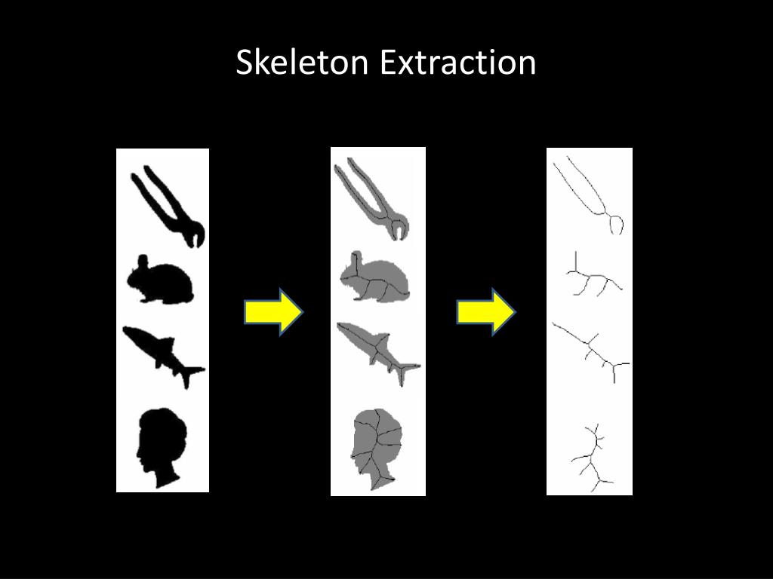

GITHUB LINK- https://github.com/marutidash8-sys/skeleton-extraction-images-OpenCV.git
NAME OF THE FACULTY- SWATIKANTA MISHRA
COMMENT:
MARK OBTAINED:
1.TITLE AND ABSTRACT
1.1TITLE
SKELETON EXTRACTION FROM IMAGES

1.2ABSTRACT
Skeleton extraction is the process of reducing objects in an image to their minimal structural form while preserving the essential geometry. This project implements a morphological skeletonization technique using Python and OpenCV. The method uses iterative erosion and opening operations to derive a thin representation of objects in binary images. The results show efficient skeleton extraction suitable for applications in shape analysis, biometric processing, medical imaging, and object recognition. This report describes the methodology, implementation, results, and possible improvements.

2.INTRODUCTION
2.1INTRODUCTION
Skeleton extraction (also called thinning or medial axis extraction) is an important technique in image processing that converts a foreground object into a one-pixel-wide representation. This representation retains the overall shape and structure, enabling simpler analysis for various applications such as:
1.Character recognition
2.Road or vein network extraction
3.Biometric recognition
4.Medical imaging
5.Shape matching
OpenCV provides powerful image processing functions, making it suitable for implementing morphological skeletonization.
3.UNDERSTANDING THE PROBLEM/PROJECT
3.1TASK/PROBLEM
You are building a system that takes an input image and extracts its skeleton — a thin-line representation (1-pixel wide) of the main shape or structure within the image.
Skeleton extraction (also called thinning) is widely used in:
1.Computer vision
2.Medical imaging
3.Handwriting recognition
4.Object structure analysis
3.2WHAT THE ALGORITHM DOES
Skeleton extraction reduces an object in an image to its centerlines, without changing its fundamental shape.

3.3GOAL
Your project aims to:
1.Process images using OpenCV
2.Convert them to skeletonized form
3.Analyze the extracted structure
4.Prepare a clean implementation with GitHub

4.ALGORITHM AND COMPLEXITY CALCULATION
4.1TIME COMPLEXITY
Erosion and dilation ≈ O(M × N)
Total ≈ O(K × M × N)
≈ O(M × N) on average.

4.2SPACE COMPLEXITY
Intermediate images stored → O(M × N)

4.3SKELETONIZATION ALGORITHM
Morphological skeletonization algorithm:
1. Start with a binary input image.
2. Create a structuring element (3×3 kernel).
3. Repeat until image erodes completely:
Perform opening on the image.
Subtract opened image from original.
Add the result to the skeleton.
Erode original image for next iteration.

4.4TOOLS USED
1.Python 3.x
2.OpenCV
3.NumPy

5.IMPLEMENTATION
import cv2
import numpy as np
img = cv2.imread('image.jpg', 0)
_, img = cv2.threshold(img, 127, 255, cv2.THRESH_BINARY)
size = np.size(img)
skel = np.zeros(img.shape, np.uint8)
element = cv2.getStructuringElement(cv2.MORPH_CROSS, (3, 3))
done = False
while not done:
opened = cv2.morphologyEx(img, cv2.MORPH_OPEN, element)
temp = cv2.subtract(img, opened)
skel = cv2.bitwise_or(skel, temp)
img = cv2.erode(img, element)
zeros = size - cv2.countNonZero(img)
if zeros == size:
done = True
cv2.imwrite("skeleton_output.png", skel)

6.APPROACH AND EXAMPLE
6.1APPROACH
Approach (Step-by-Step)
Step 1 — Image Preprocessing
1.Convert image to grayscale
2.Apply thresholding or adaptive threshold
3.Convert to binary
Step 2 — Apply Skeletonization
Choose one:
1.Morphological skeleton
2.Zhang-Suen thinning
3.Medial axis transform (skimage)
Step 3 — Post-processing
1.Clean small noise pixels
2.Smooth skeleton lines
3.Save output
Step 4 — Display or use skeleton
1.Save skeleton image
2.Show input vs output

6.2EXAMPLE
Input
An image of a handwritten digit “5”.
Steps
1. Convert to grayscale
2. Threshold to binary
3. Apply thinning
4. Final skeleton has 1-pixel width
Expected Output
A thin-line version of the number "5".

7.RESULTS AND SCREENSHOTS

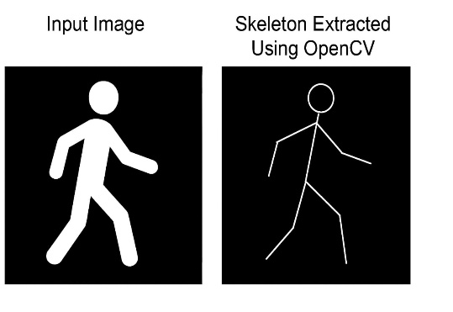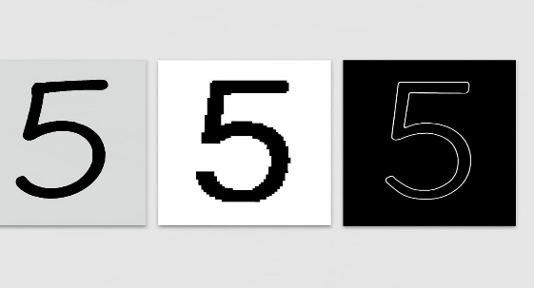
8.CONCLUSION
Skeleton extraction using OpenCV offers a simple and powerful way to derive shape structures. Morphological skeletonization is suitable for clean binary images but may produce branches when noise exists. The method is computationally efficient and ideal for educational and research purposes.

9.FUTURE ENHANCEMENTS
1.Use deep learning models like HED / DeepSkeleton.
2.Extend to color and natural images.
3.Real-time skeleton extraction from video.
4.Apply pruning algorithms for cleaner skeleton.

10.GITHUB REPOSITORY
https://github.com/marutidash8-sys/skeleton-extraction-images-OpenCV.git

